8K Sector Copier Instructions 1

Introduction 1

Running ADAM 2

Files on the Disk 3

8KCOPIER.ADM 3

8KCopier.BAS 4

8KLEVELC.ADM 4

8KSECTAG.ADM 5

BATLOAD.ADM 7

BATMAN.ADM 7

UTILTY.BAS 8

# 8K Sector Copier Created by Jason Brooks (aka Argonaut) 1990

# Introduction

In 1990 Speedlock created a disk protection system for the Amstrad CPC which ensured that standard hardware could not copy the disk.

The Disk sector parameters were modified such that any program reading the information would be presented with a single sector per track size of 8K, however physically the disk could only hold a maximum of 6k data per track.

You could fool the disk controller to format a sector with 8K by modifying the same parameters, however when formatting and writing the data to the sector, there was an inevitable overrun invalidating the disk and would appear to be corrupt/unformatted.

Conversely, reading 6K sectors was a trivial task since you can set the maximum amount of data to read into a buffer.

Hackers including myself took on the challenge, trying to spin the disk and stop the motor such that the additional data would not overwrite the sector information/overlap the data on the track.

These attempts all failed, it was possible to achieve this by modifying the Amstrad CPC hardware by adding transistor to the write signal but this was impractical and with risk to all by the hardened enthusiast.

I approach the problem in a different way. We’d been quiet adept at breaking various protection systems, transferring tape to disk over the years, and so this problem was simply one of transferring files from a protected disk to one that could be read and copied by any copier on the market.

Intercepting the decryption routines to find the loader, load the game code and then write this to disk. Some games had additional levels, and as such didn’t use the 8K Sector format but standard Data/Vendor formats so it was possible to copy the game level sectors using a combination of cracking the main game, and copying the game level data.

The code I have shared with you, worked on the examples of 8K Sector Disks I could find at the time, but it doesn’t mean that it’s completely fool proof.

My main assembler of choice was ADAM (Assembler/Disassembler and Monitor) also known as DAMS in Europe. It was probably one of the most underestimated tools available to hacking and development, using a combination of loading the application into a 6128 rambank it was possible to speed up development.

Of course I had Maxam, but because of the tokenisation of code and built in monitor tools it was (in my opinion) the best on the market for the humble CPC.

Of course, 28 years later, I’m sure there are better people than I who can make use of this code for education purposes.

# Running ADAM

Insert the disk and type

RUN”ADAM”

This will automatically load into ram address &4000 (16384 Decimal)

If you have a CPC6128 you can issue the following

OUT &7F00,196

This will load ADAM into RAM 4 at address &4000

Should you crash your code, or reset your Amstrad, usually switching back that rambank and call &4000 will get you back up and running without loading the tool.

All ADAM Source files will have the file extension **.ADM**

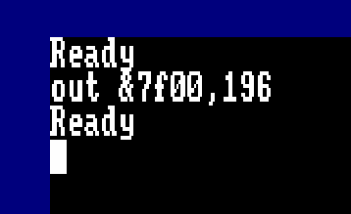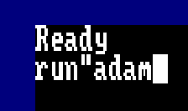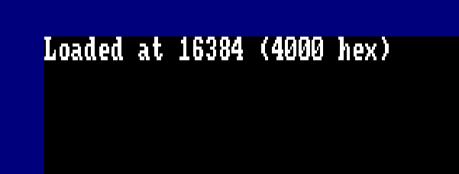

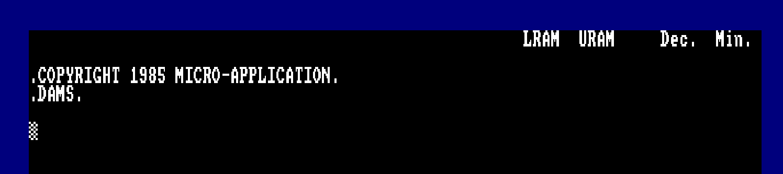

# Files on the Disk

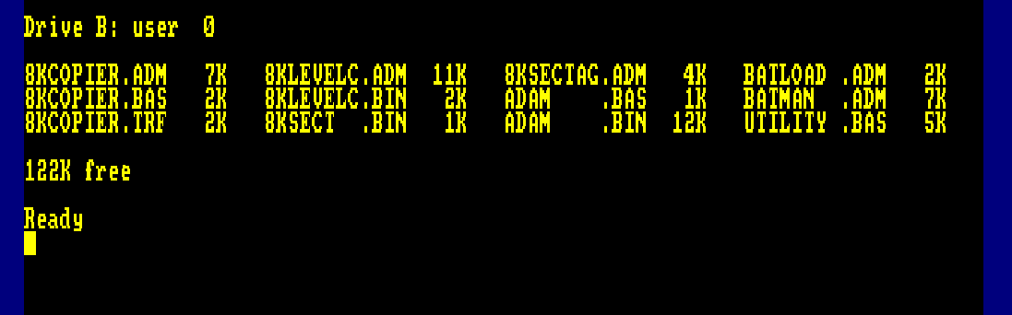

## 8KCOPIER.ADM

To Assemble this code, from within ADAM use the following :-

Press CTRL+B to enter HEX Mode

g0,8kcopier.adm

a2

p2,8kcopier.trf

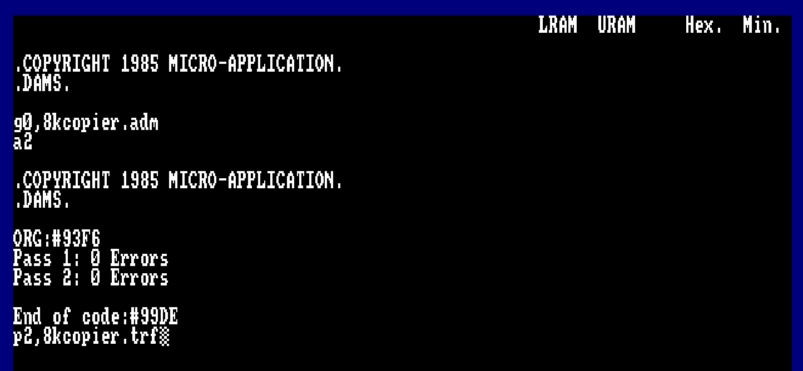

G0 will Get the file from disk.

A2 will assemble the code at the first available address space after the assembler has loaded. We use this command as I have relocating code and different ORG Addresses.

P2 will Put the object code onto disk.

X1 will display the symbol table if you’re interested.

More instructions on the use of ADAM can be found here

<https://cpcrulez.fr/download.php?a=VIesnZvWgsLl2M69gsbe29PNgLXk0M7IiH_ZzdLNT7rp2Q>==

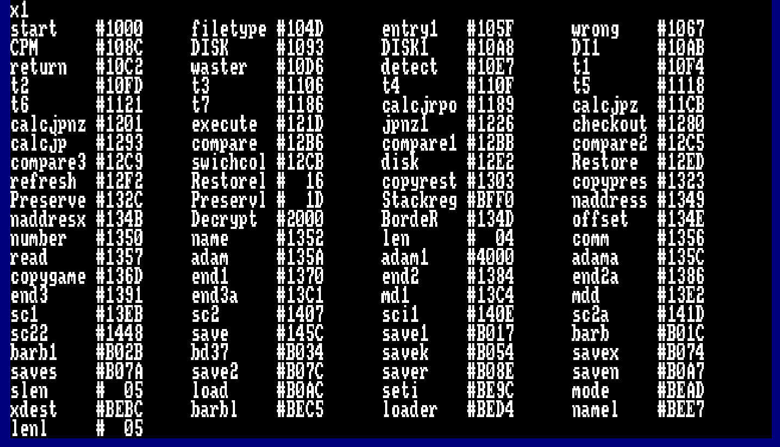

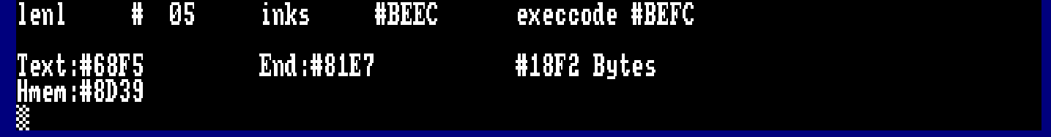

## 8KCopier.BAS

This is the basic file for loading and executing the 8K Copier Code

LOAD”8KCOPIER.BAS”

LIST

RUN

Follow the instructions

## 8KLEVELC.ADM

To be able to assemble this, you will need to load ADAM into a lower memory address.

RUN”ADAM

Immediately after hitting enter, hold down the SPACE bar and you are presented with the option of a loading address.

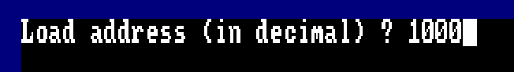

Enter 1000 and hit enter

Once loaded enter the following commands :-

CTRL+B to enter HEX Mode

G0,8klevelc.adm

A2

P2,8klevelc.bin

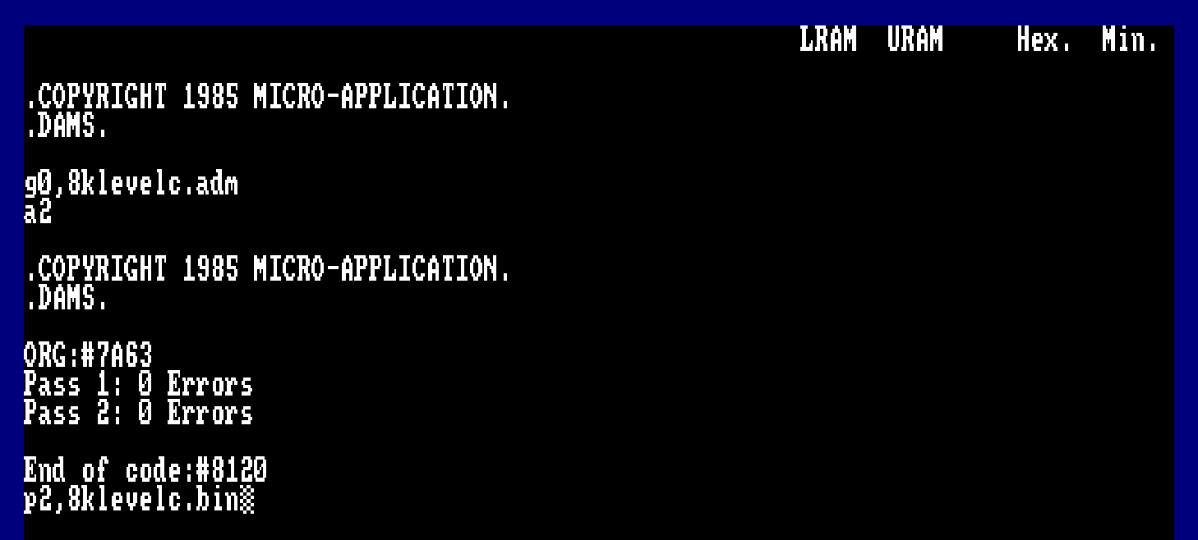

## 8KSECTAG.ADM

G0,8ksectag.adm

A2

P2,8ksect.bin

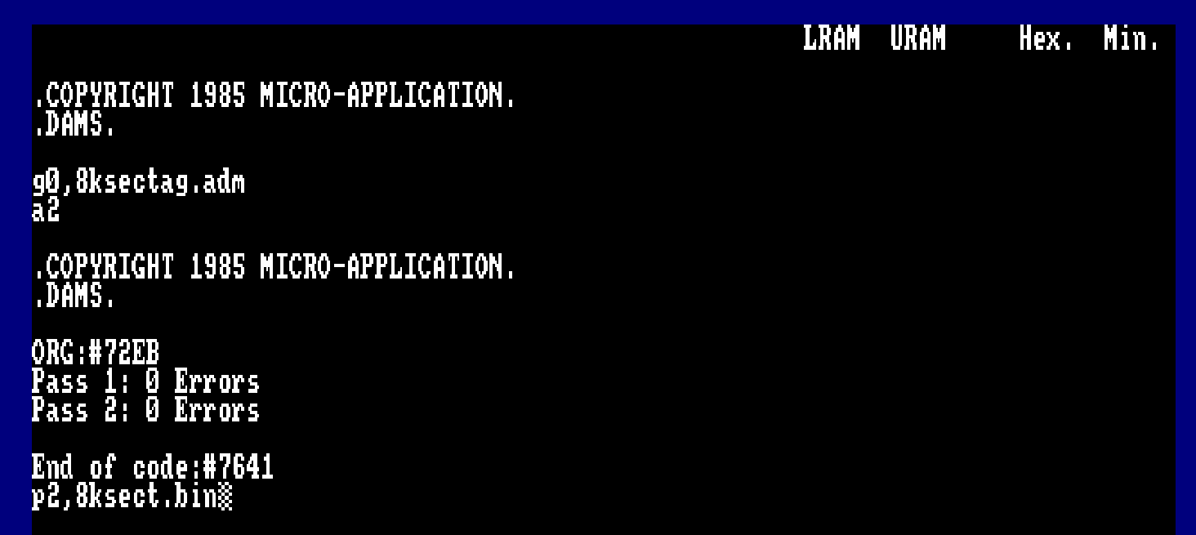

## BATLOAD.ADM

This will load the Batman game and offer a cheat mode.

G0,batload.adm

A2

P2,batload.bin

B

Run”batload.bin”,&8000

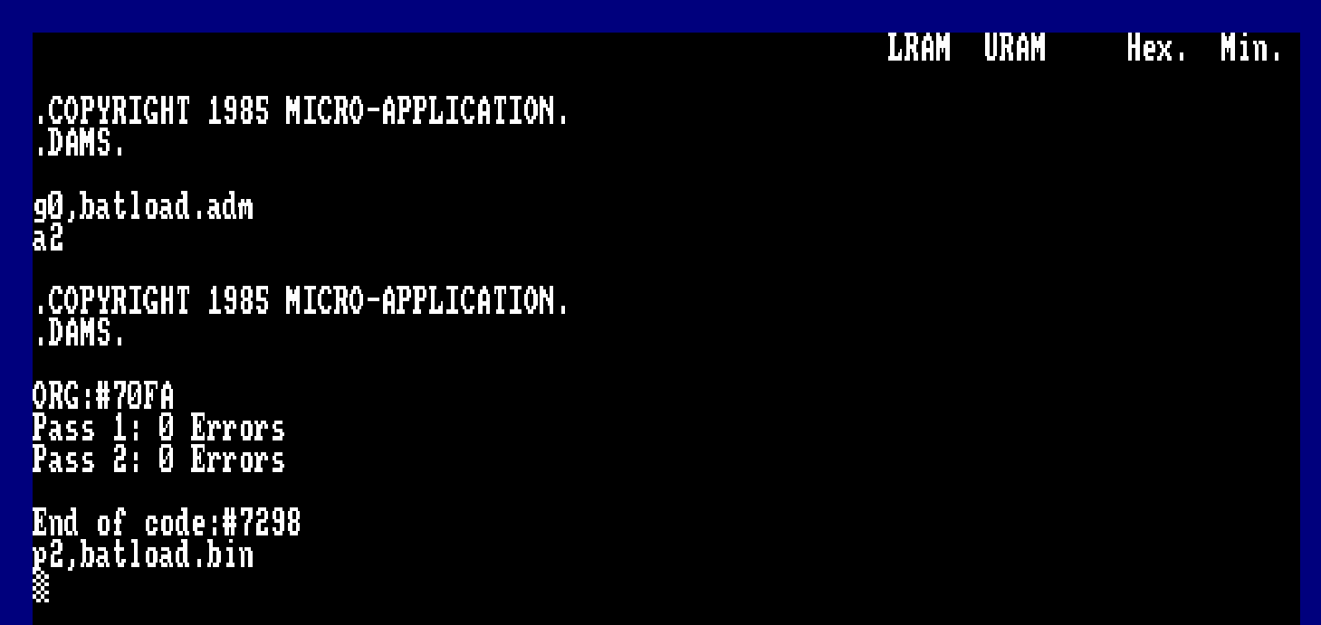

## BATMAN.ADM

The Speedlock decoder for Batman the caped crusader

G0,batman.adm

A2

P2,batman.bin

B

RUN”BATMAN.BIN”,&3000

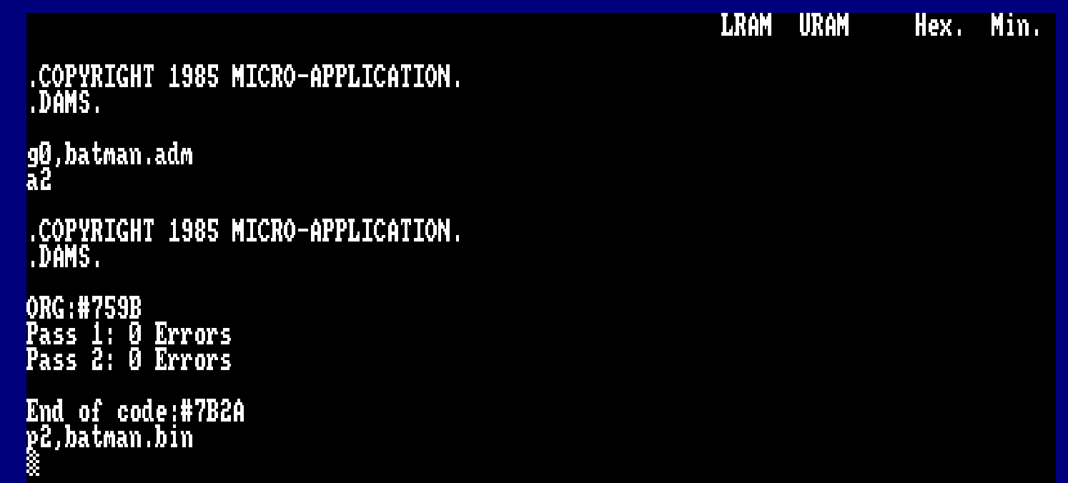

## UTILTY.BAS

This utility will attempt to copy game level sectors for you on the cracked 8K loader

RUN”UTILITY.BAS”

